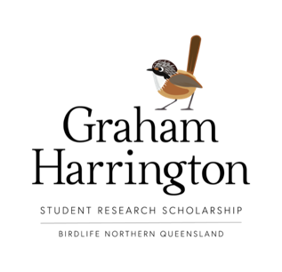

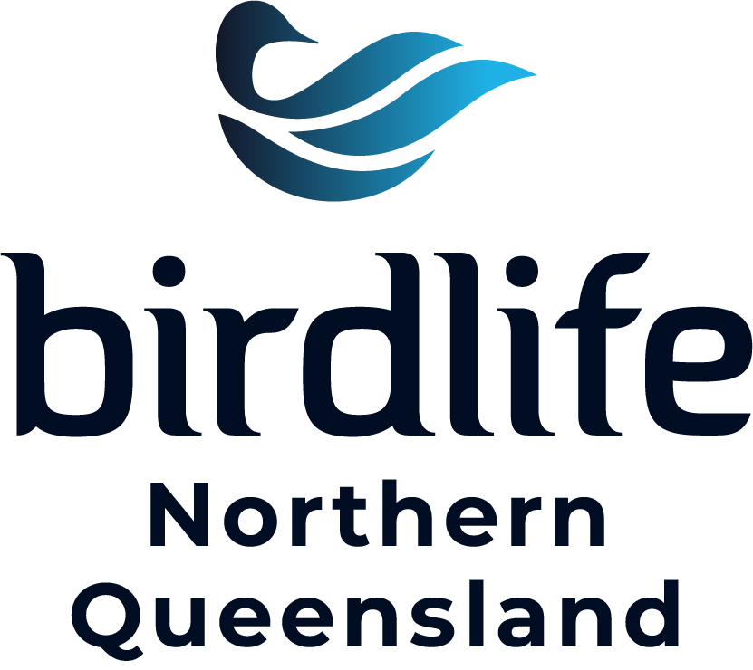

APPLICATION

Applicant details
Applicant name
Applicant address
Daytime telephone
Email address
Institution name
Institution address

Department
Supervisor’s name

Supervisor’s phone and email

Secondary supervisor’s name

Secondary supervisor’s phone and email

About your research project
Project title
Brief description of project (max 200 words)
Project aim (max 100 words)
What are the anticipated conservation outcomes of your research? (max 200 words)
Project methodology (max 100 words)
What are the start and finish dates of your research project?
If this is longer than a one year project, identify milestones and outcomes to be completed within this academic year
If successful, how do you intend to spend the grant funds (excludes conferences)?
How do you intend to communicate your research? e.g., papers, presentations

Additional information
Curriculum vitae (short)
Other documentation in support of your application e.g. papers already published (optional) | NB Include Supervisor letter of support.

Acceptance
I agree to these conditions:
- A final report submitted at the conclusion of my research.
- Acknowledgement of BirdLife Northern Queensland in all papers and presentations.
- Short (popular) article submitted to BirdLife Northern Queensland Newsletter.
- A public talk / presentation to BirdLife Northern Queensland (if feasible).
Applicant’s signature
and date

APPLICATIONS CLOSE 31 MAY 2023 • APPLICANTS NOTIFIED JUNE 2023

Application form including attachments to be emailed to BirdLife Northern Queensland: northernqld@birdlife.org.au

